Bloody Mary
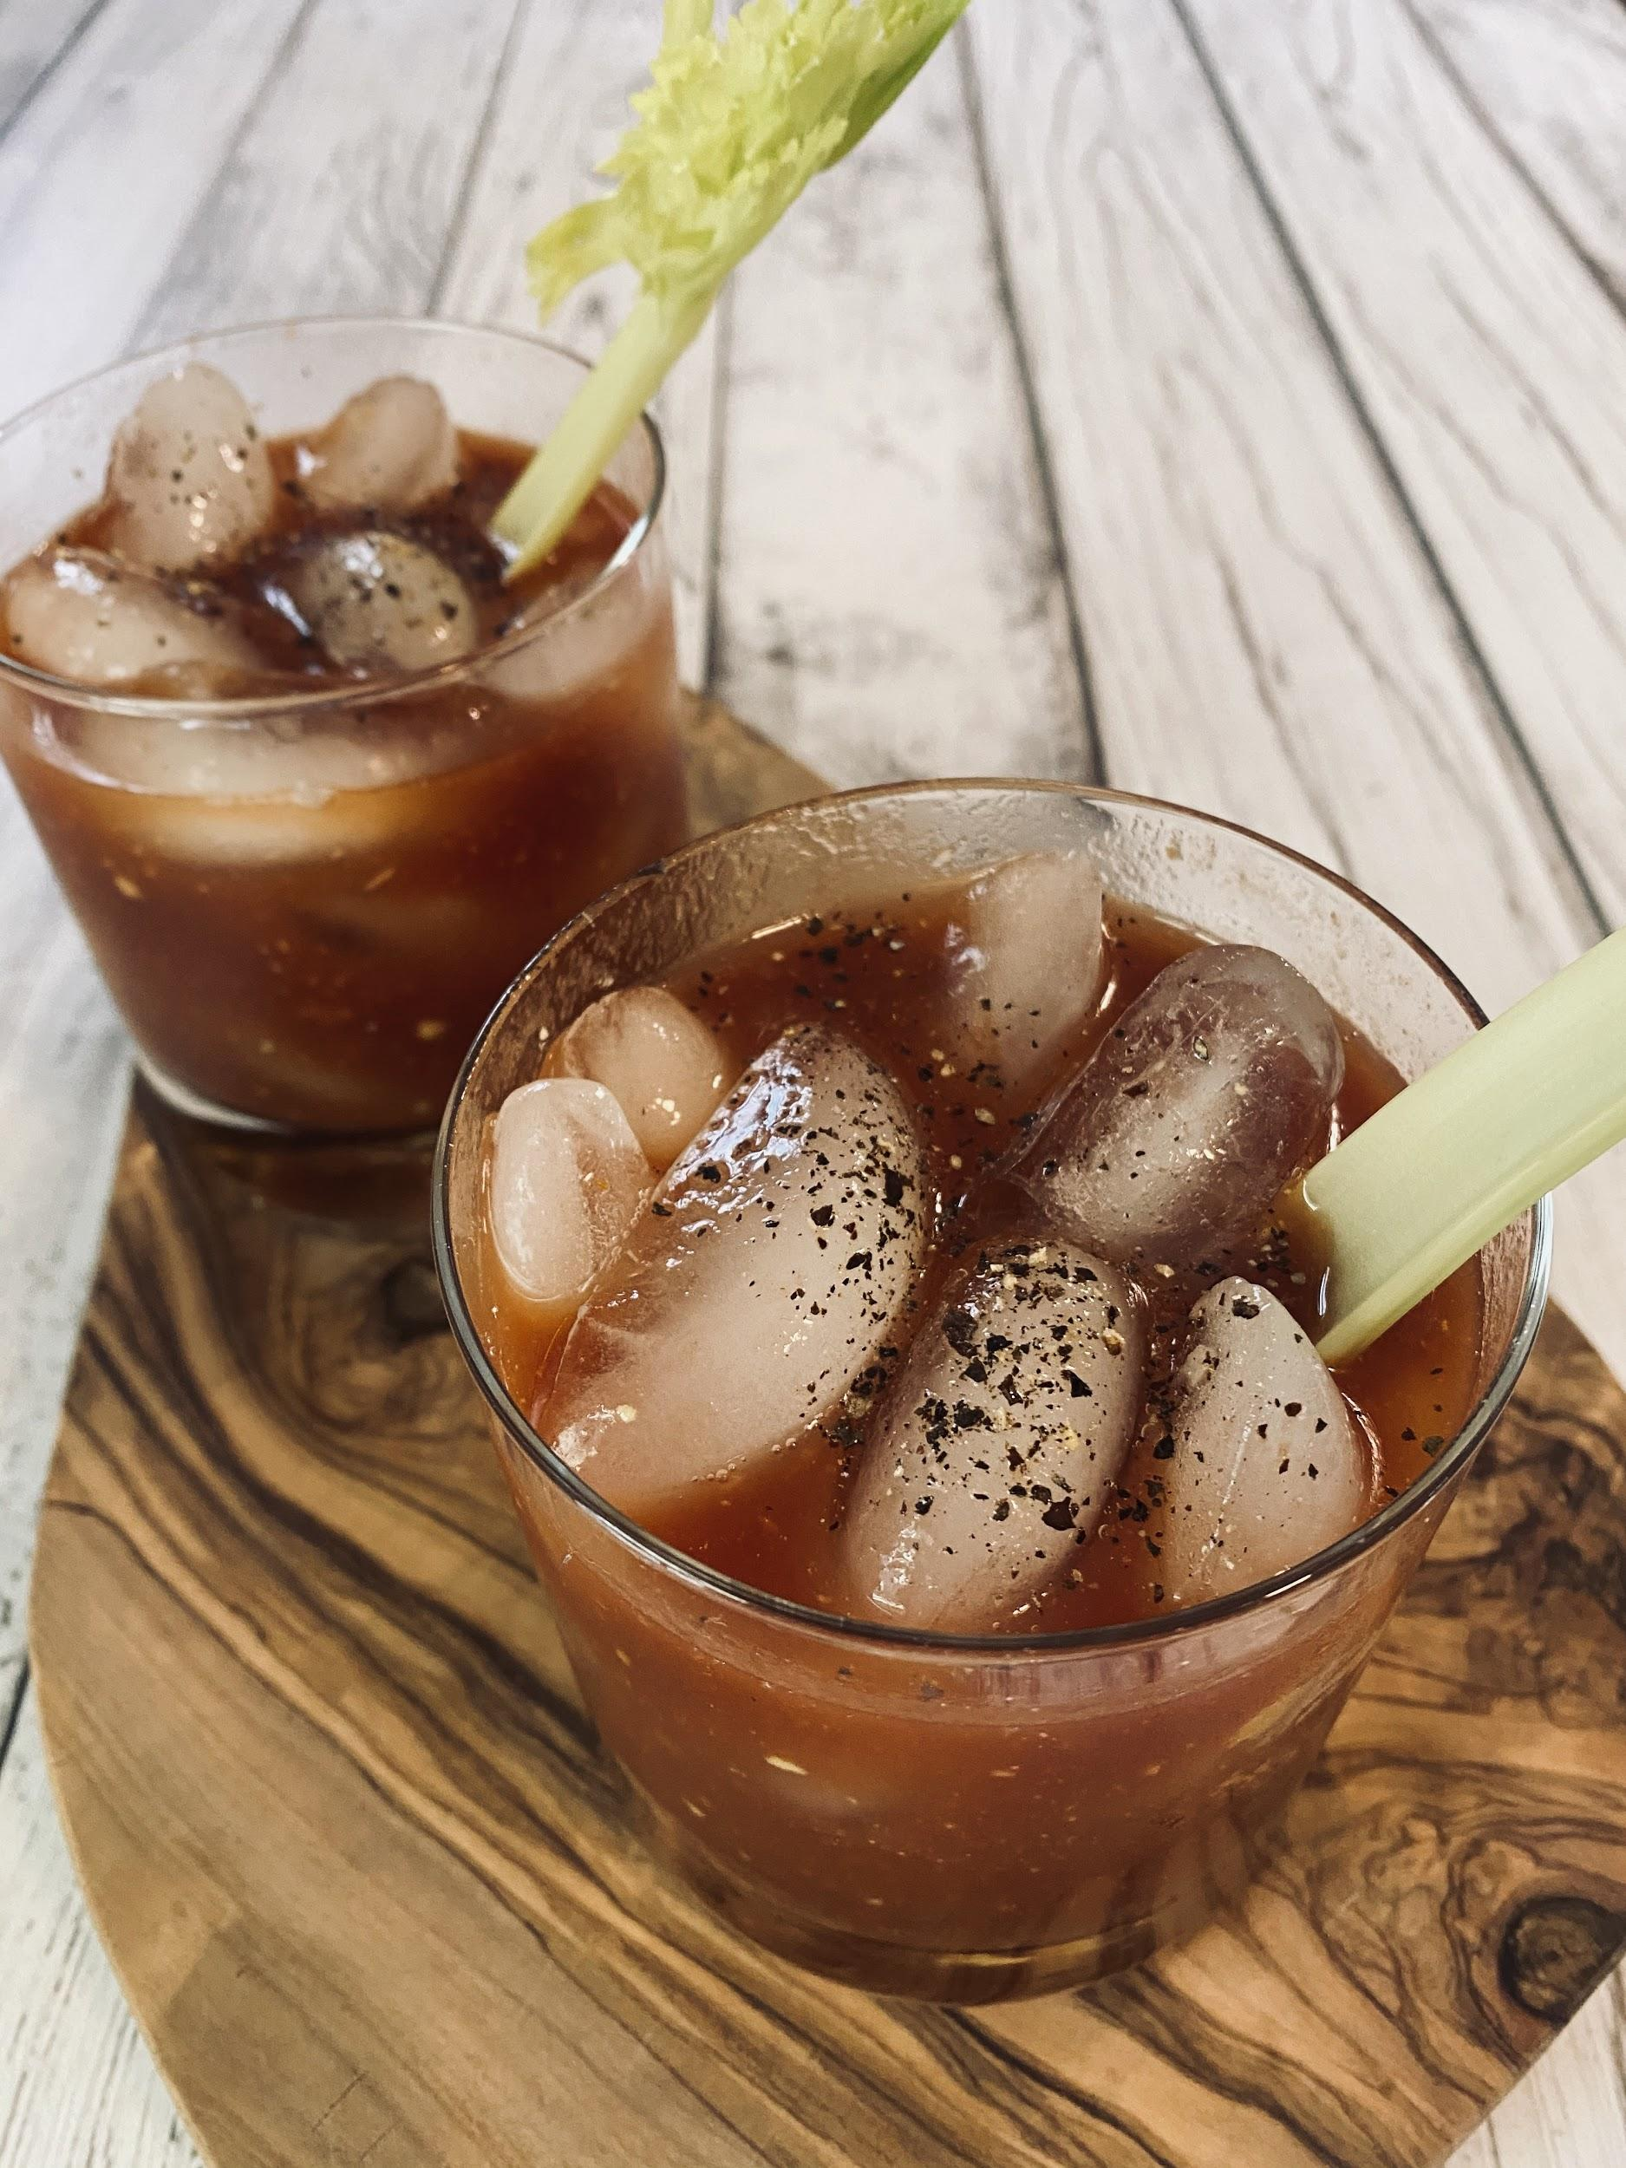
Recipe and photo by Jennifer and Ludovic, Behind the Bar

Ingredients:
- 1 tsp lemon/lime juice
- Couple dashes of bitters
- 1 tsp Worcester sauce
- ½ tsp horseradish (to taste)
- ½ tsp dijon mustard (optional)
- Tomato juice
- 1-1 ½ ounces vodka
- Splash of sherry (optional)

Garnish ideas: black pepper, celery, lemon or lime wedge, green olives

Directions:
- Fill glass with ice
- Add lemon/lime juice, bitters, worcester sauce, horseradish and dijon mustard.
- Add tomato juice, filling the glass a little more than half way.
- Add vodka and a splash of sherry.
- Stir well and add garnish if desired.

Santé!

